**Databases Summary:**

**AWS Database Type – Summary:**

* RDS – OLTP
  + SQL
  + MySQL
  + PostgreSQL
  + Oracle
  + Aurora
  + MariaDB
* DynamoDB – No SQL
* Redshift - OLAP
* Elasticache – in Memory Caching
  + Memcached
  + Redis

**What is a Multi AZ?**

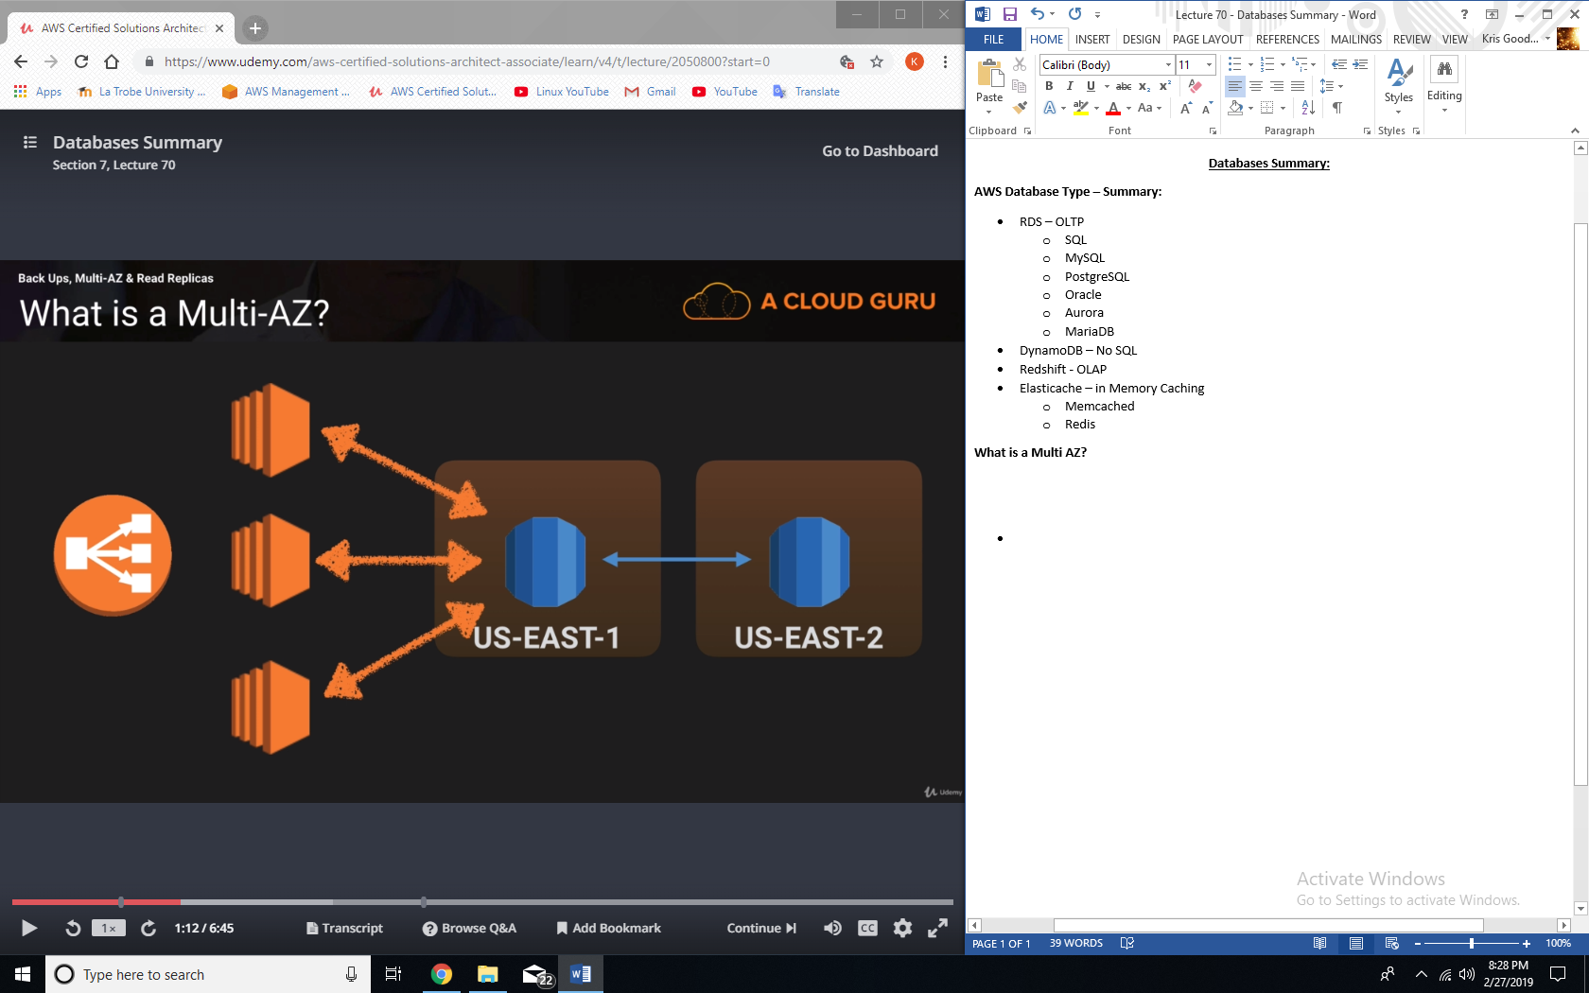

**What is a read replica?**

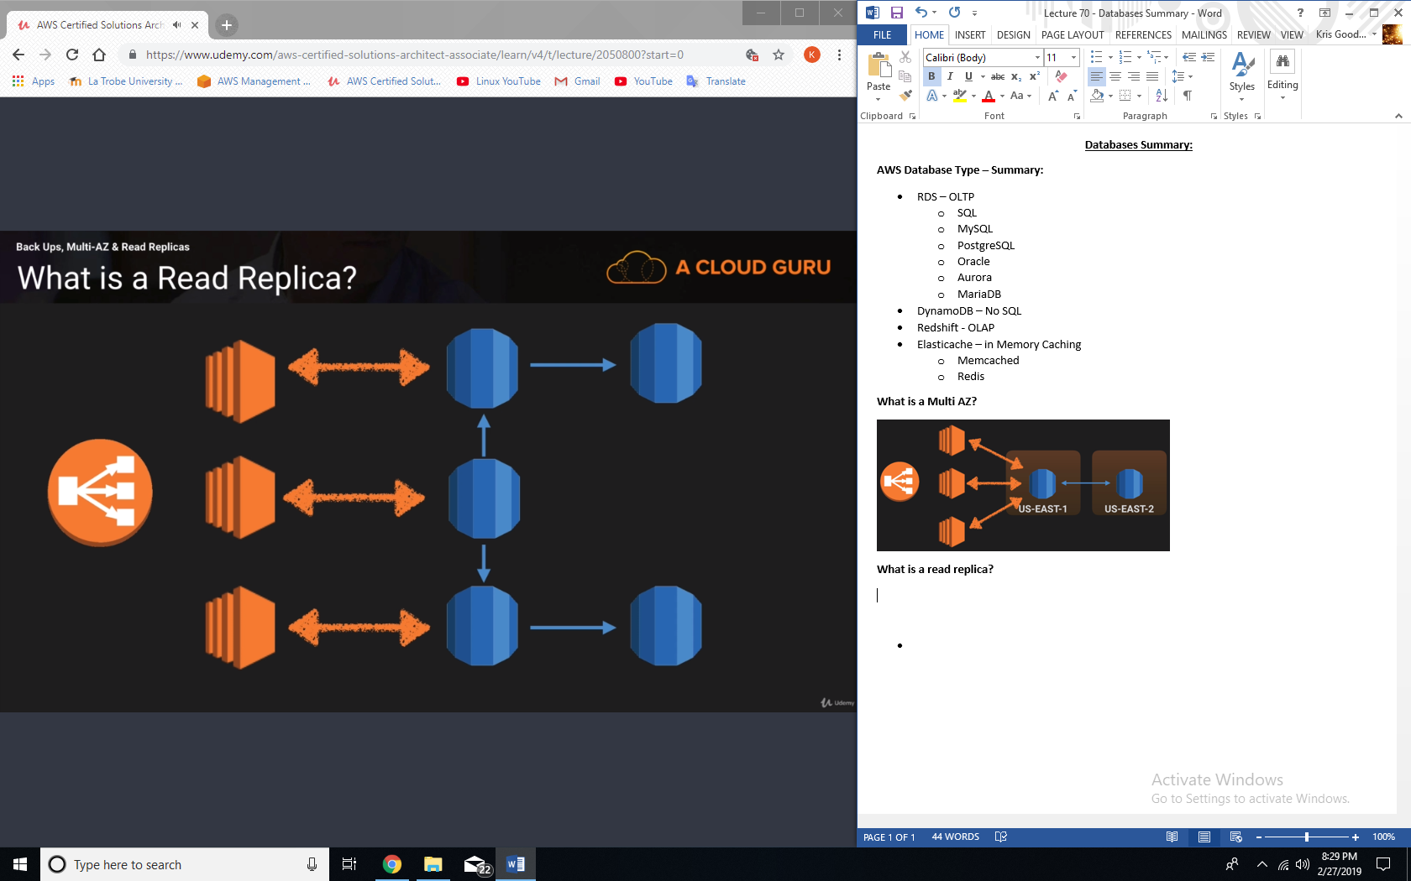

**Aurora Scaling:**

* 2 copies of your data is contained in each availability zone, with minimum of 3 availability zones. 6 copies of your data.
* Aurora is designed to transparently handle the loss of up to two copies of data without affecting database write availability and up to three copies without affecting read availability.
* Aurora storage is also self-healing. Data blocks and disks are continuously scanned for errors and repaired automatically.

**Aurora Replicas:**

* 2 types of Replicas are available.
  + Aurora replicas (currently 15)
  + MySQL read replicas (currently 5)

**DynamoDB vs RDS:**

* DynamoDB offers “push button” scaling, meaning that you can scale your database on the fly, without any down time.
* RDS is not so easy and you usually have to use a bigger instance size or to add a read replica.

**DynamoDB:**

* Stored on SSD storage.
* Spread across 3 geographically distinct data centers
* Eventually consistent reads (default)
* Strongly consistent reads.

**Redshift Configuration:**

* Single node (160Gb)
* Multi node
  + Leader node (manages client connections and receives queries.
  + Compute node (store data and perform queries and computations). Up to 128 compute nodes.

**What is Elasticache?**

* Elasticache is a web service that makes it easy to deploy, operate, and scale an in-memory cache in the cloud. The service improves the performance of web applications by allowing you to retrieve information from fast, managed, in-memory caches, instead of relying entirely on slower disk-based databases.
* Elasticache supports two open-source in-memory caching engines:
  + Memcached
  + Redis